

General Info

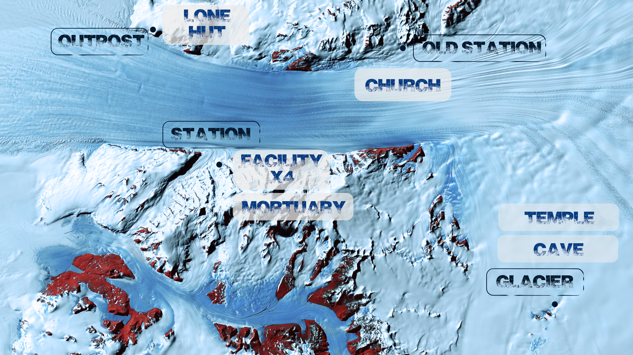

In this game, we have more locations, but we can deal with them in two different ways. Because there are locations inside the locations. So you get to the Outpost in the beginning, you're outside of the hut in the snow. You open the hut and get in. So there are two locations - exterior and interior. If it's possible, i'd suggest not making the interior locations as separate points on the map. So if you want to get into the hut, you go to the outpost location and click on the door of the hut. If it's not possible, all locations are separate points on the map.

Intro

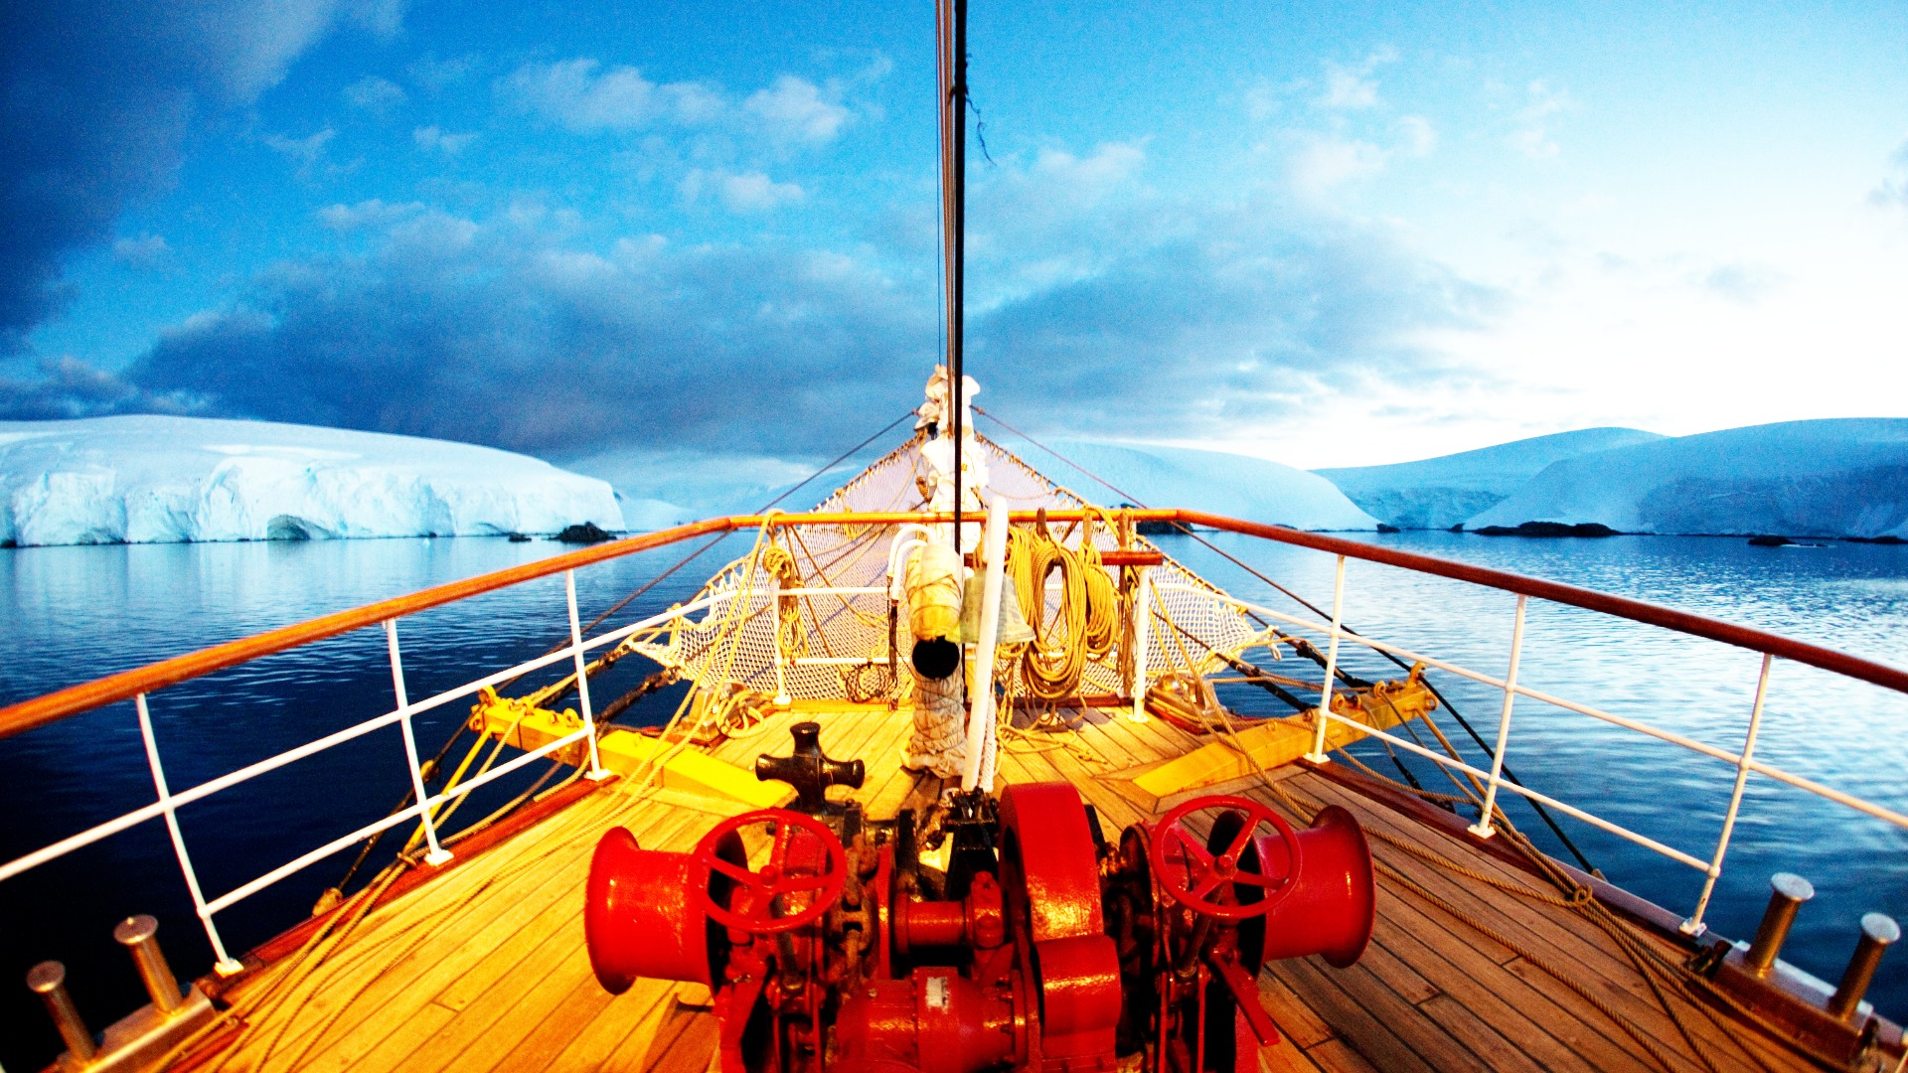

The intro is shown with a background showing a ship sailing the Arctic waters. The same ship will be the last location the players visit.

Unlike the previous games, this time the intro is in the form of a dialogue, instead of a letter. It can either start automatically or open when the player clicks anywhere on the screen (so before that they only see the bow of the ship and glaciers in front of them).

*~~"You can hear the captain's voice:~~*

*~~"You weren't supposed to arrive for another two months, weren't you? I know, I know. There's some conflict on the station and they requested you go in to replace their crew early. But you know what? They are gonna pay you double for that. If you can make more - make more, that's my philosophy.~~*

*~~Though I can't imagine what sort of conflict can there be between Charlie and Roger. Do you know them? The two main guys in the expedition?~~ ~~Well, I know them, the fools. I'm the one who got the crew to the Station a few months back. Smart guys, tough guys, but fooling around like children, you know? Roger, for example, never used to lock the trunk with his personal belongings, even though it's protocol, so Charlie put his own lock on Roger's trunk. Said: "well, it's mine now then" and refused to give the code. I mean, these are grown men… ah, well.~~*

*~~Anyway, at least they've found something interesting while drilling the glaciers. I doubt it's anything big, since they only sent word once about that and then never contacted the mainland again, before summoning you, but it's at least something to look forward to…~~*

*~~Ah, we're almost there. Pack up. Roger will meet you at the Outpost and drive you to the Sigma Station. "~~*

Outpost

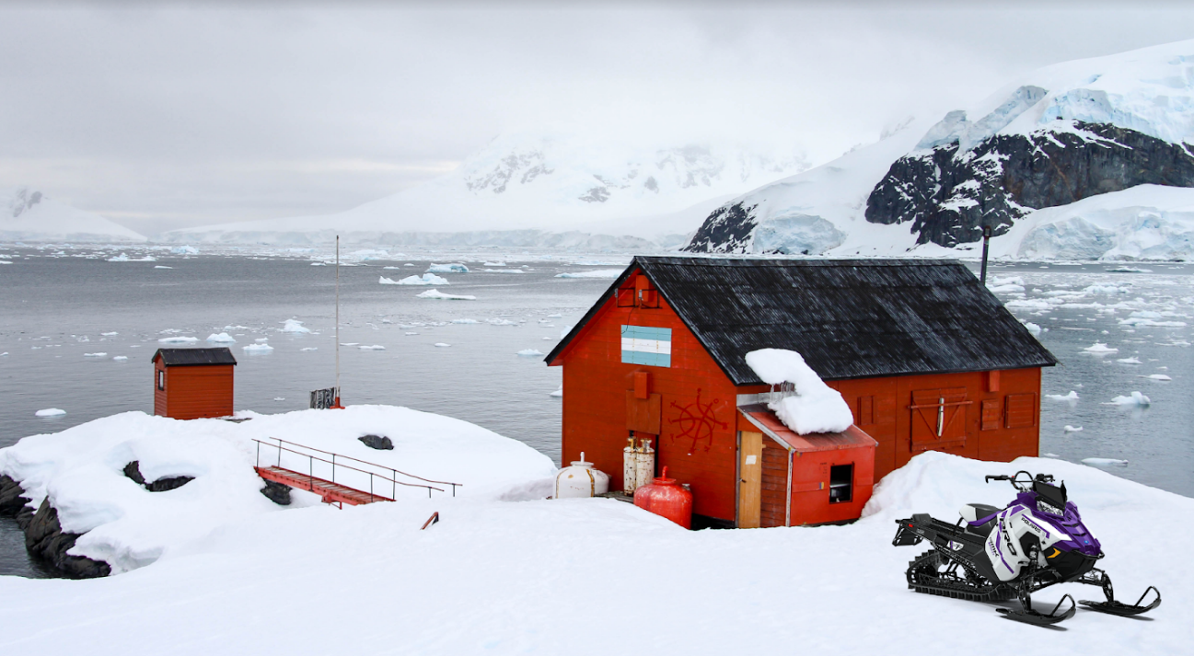

1. Letter

Picture: A frost-covered piece of paper stuck to the outside of the hut.   
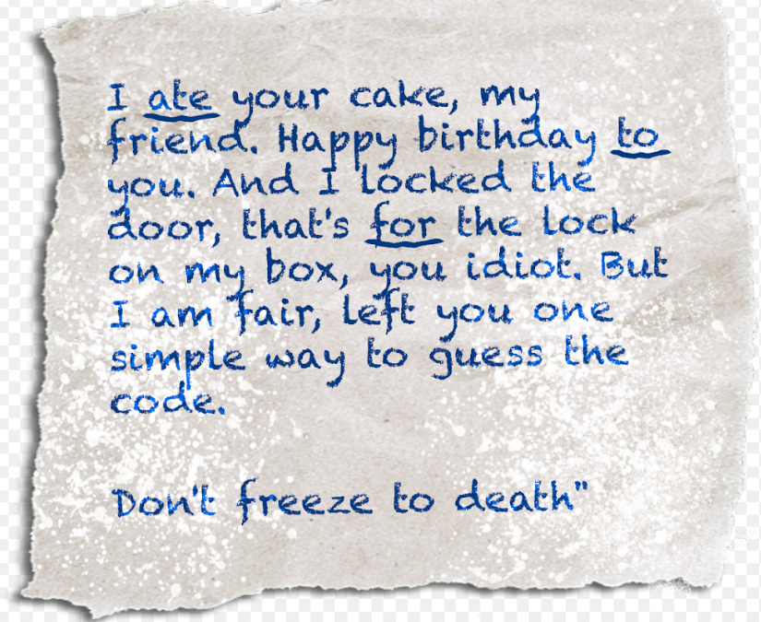

Text: *"I ate your cake, my friend. Happy birthday to you. And I locked the door, that's for the lock on my box, you idiot. But I am fair, left you one simple way to guess the code.*

*Don't freeze to death"*

Very mature. These two are life-long friends, so it must be their way of showing affection. Yeah, as the captain said… fools.

1. Door  
   Picture: A combination lock on the door.  
   

Text: *"The hut is locked and there's no sign of Roger. Damn. He's supposed to be waiting here to take you to the Sigma Station. You think it's better to get out of this freezing cold and figure out what to do next. There's a 4-digit combination lock in the way though."*

Answer: The players need to read the letter on the door. The 4 digits for the code are hidden in the text. Ate, to, for, one. **8241**.

Lone hut

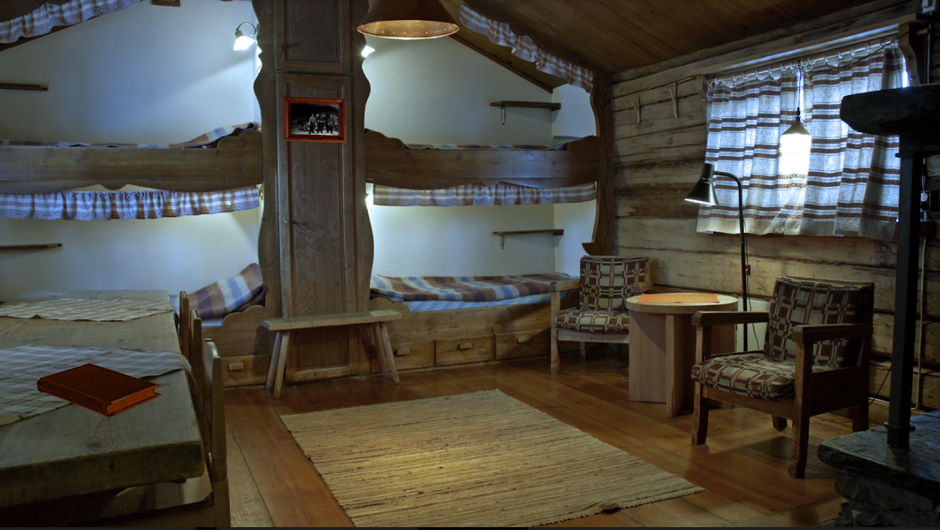

1. Bed before sleeping

Picture: A bed

Text: *"Damn, but you feel tired. And it's so warm and calm here. Roger might be here soon, so you can just take a little nap and wait for him..."*

Button: Sleep

Basically, it's just like solving the puzzle and pressing ok, but on answer needed here.

1. Bed after sleeping

Picture: Blurry shapes with the bed in the background.

Text: *"Such a strange dream… a nightmare. You heard a voice, deep and disturbing, calling for you from beneath the ice. And then you saw the cabin and two blurry shapes, two men shouting at each other, one takes a swing, the other stumbles back… you heard a sound of shattering glass, the small yellow window broke and something flew out of it, jingling… and that deep voice again… calling your name..."*

1. Diary

Picture: An opened diary

Text: Roger's diary.  
*"Will just fixed the communication system. I called in the replacement team. I had to. Maybe they can do what I couldn't.   
Charlie will be here soon, I'll try to reason with him. I suspect he knows, how to open THE DOOR. He must let us in, he must understand that it won't end well otherwise.*

*Coming in, I saw the letter, still hanging on the wall of the hut. Like a grim reminder of what our relationship was before we found IT… I wish we could go back to that. But I don't think we can.*

*If Carlie won't show, I'll ride due norht to the statin proper, and will deal with him there."*

Outpost

1. Snowdrift

Picture: A snowdrift with a shiny key laying on top of it.  
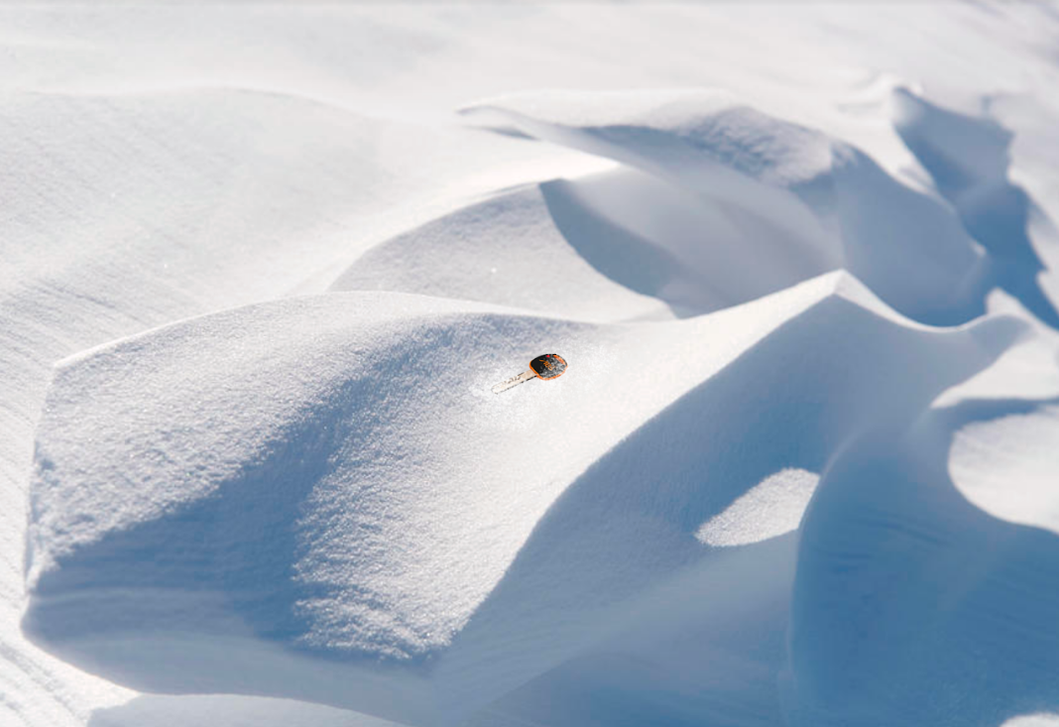

Text: *"Was it a dream? Two men fighting… then something flew out of the window… a key to a snowmobile, it would seem."*

Button: Take the key

The players are guided by the description of the vision in their nightmare. Something flew out of the yellow window. All the players need to do is to find the widow in the Outpost location and look for a small clickable spot beneath it. So this is a search puzzle, and this spot beneath the window should not be active before they sleep.

1. Snowmobile

Picture: A snowmobile

Text: *"Roger is nowhere to be seen. You can get to the station yourself, all you need is the key and the right direction."*

Answer: Due north.

Button: use the key  
NB: The button is inactive until the players find the key. If that can't be done in the current setup, this can be done in two steps. First, the text above + the button "use the key".   
Then the text: "Direction?"  
Answer: Due north.

After that, a new location appears on the map - Sigma Station.

Sigma Station

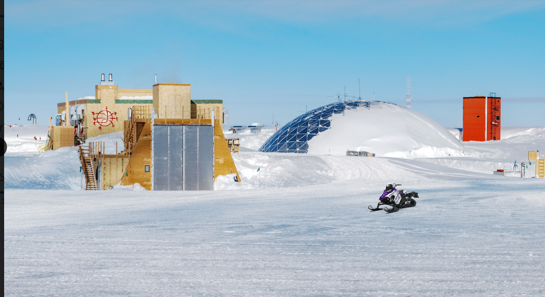

1. Facility lock  
   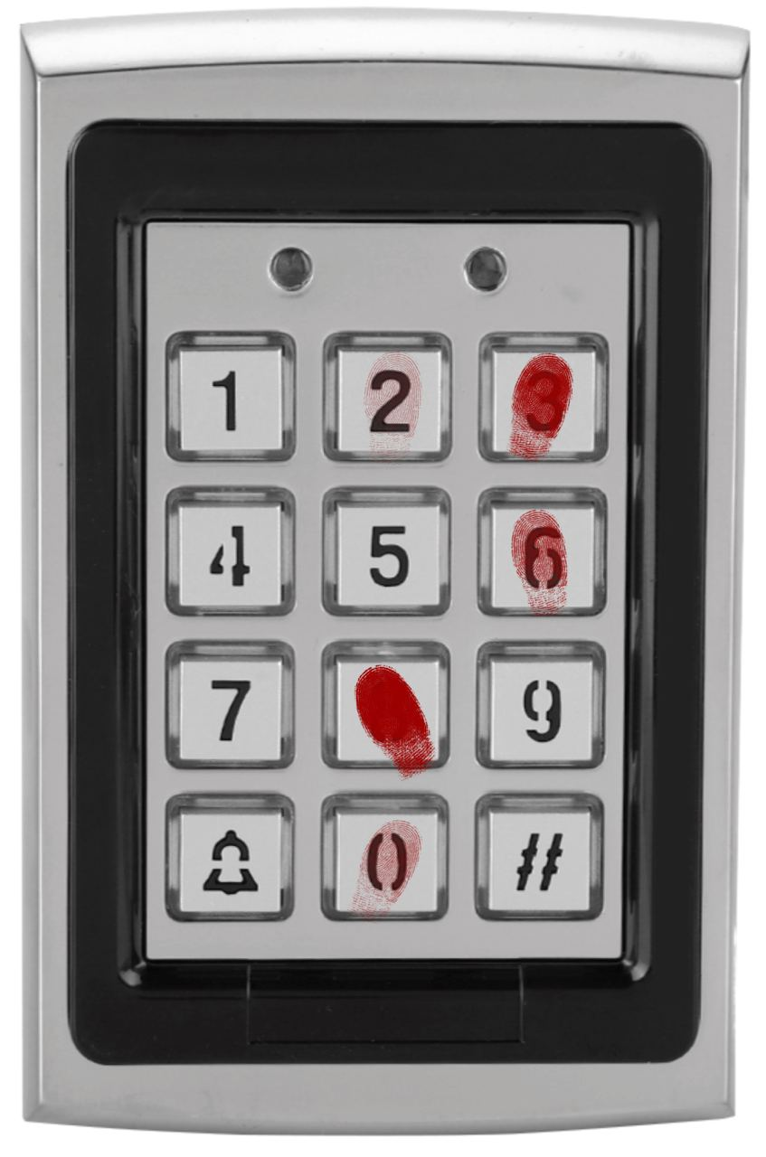

Picture: A digital lock, on it there are blood stains and 5 bloody smears on the buttons.

Text: *"It seems as if the Station is completely empty. No one answers your calls. And there's blood on the lock to the main facility… what the hell happened here?"*

***ANSWER: 83602***

The players need to look at the stains, they are different in how pronounced, thick they are. The players need to realize that the first digit in the sequence is from the button with the thickest coating of blood, the next one is more transparent and so on. The person that pressed the buttons had blood on their hands and the further they got in the code, the less blood they left on the buttons.

Facility X4

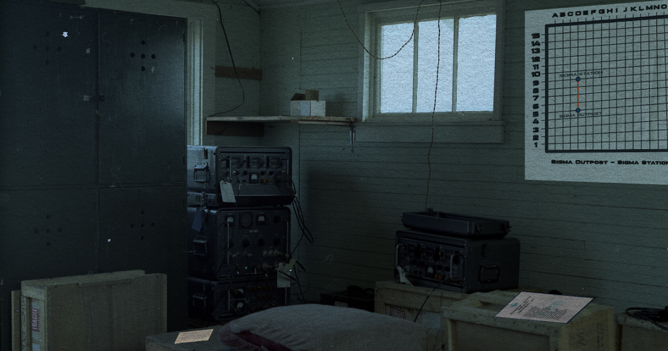

1. Diary

Picture: Another one written in Roger's hand

Text: *"This is an incredible discovery. I still can't believe it. We just stumbled upon this ice cave and inside… a small, clearly man-made structure. I thought of it as "a temple", from the moment I saw it. It has a door, that we tried and failed to open… I wonder what's hidden there.   
Who could've built that, here in the Arctic? No information in any database of something like that. The Soviets? The Brits? And most importantly - why? Why would you build something like that…*

*No answers. But there is something else. The nightmares. The whole crew seems to be experiencing vivid and strange dreams since we've found it. Tom Willford was the first to report hearing a voice, coming from behind the locked door in his dreams… since then others claimed to have experienced the very same thing. And then the split happened. I'll ask Tom's brother to write a report on that.  
  
PS used OTtFfSsEN code for the other facility. Charlie mustn't know what I'm planning."*

1. Employee list

Picture: An official document with the list of all the people in the station for the past few years.

Text: *"Expedition Leng-31 2018-2024 personnel list*

*Michael Maher*

*Sebastian Gillis*

*Roger Childs*

*Bethany Lord*

*Alex Rhode*

*Felix Willford*

*Stephanie Murphy*

*Charles MacReady*

*Steven Lester*

*Henry Mull*

*Anne Kane*

*William Goulde*

*Peter Walsh*

*Tom Willford*

*Nancy Merrin*

*Carry Williams*

*David Burns"*

1. Filing cabinet before finding the name

Picture: A filing cabinet

Text: *"There's a lot of documentation here, sorted by author. You can probably find something interesting here If you know what you're looking for."*

Answer: Felix Willford

The players check the personnel list and find Tom's brother, who supposedly has a report on what happened on the Station recently.

1. Filing cabinet after finding the name

Picture: A file folder

Text: *"Willford's report.  
"We wanted to report the finding, but almost half of the group urged us not to. They all appeared agitated, sleep-deprived, exhausted. And they all said we should not let anyone know about the structure we've found. My suspicion is that they sabotaged the communication system to prevent us from doing that, but I have no proof. Will Goulde is now working on restoring the system.*

*Everyone on the Station started experiencing strange psychological symptoms after the Discovery. Some claim it's something in that structure, that temple, that is affecting us. Those that want to keep it all secret, are starting to behave suspiciously. Whispering to each other, disappearing for hours at a time. I managed to follow one of them to an old abandoned Soviet outpost, to the chapel there. They are congregating in that old building and it looks like… they are worshipping this thing from the ice cave.*

*The easiest way to the chapel is: 3 km north, 7 km east, 1.5 km south from the Sigma location."*

1. Map

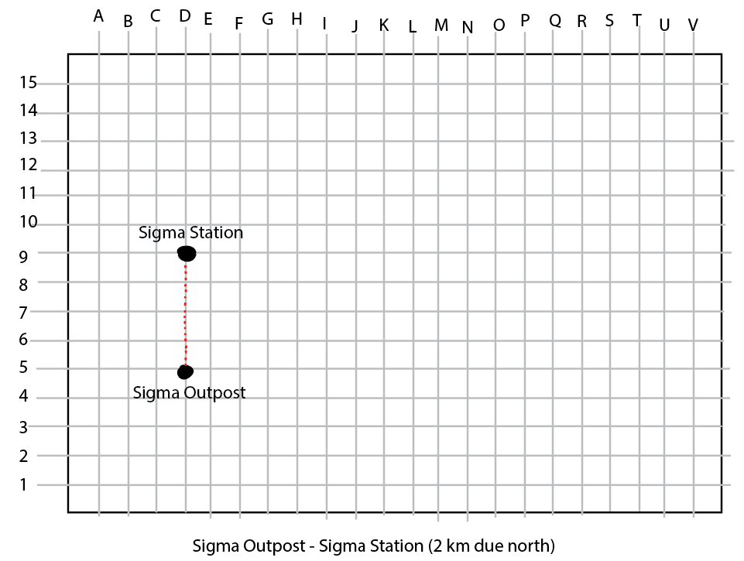

Picture: A squared map with coordinates

Text: *"A map of the surrounding area. Sigma Station's coordinates - D9."*

The players need to look at the map, figure out that 1 km = 2 squares. So they can find the location of the abandoned church - 6 squares up, 14 squares to the right, 3 squares down.  
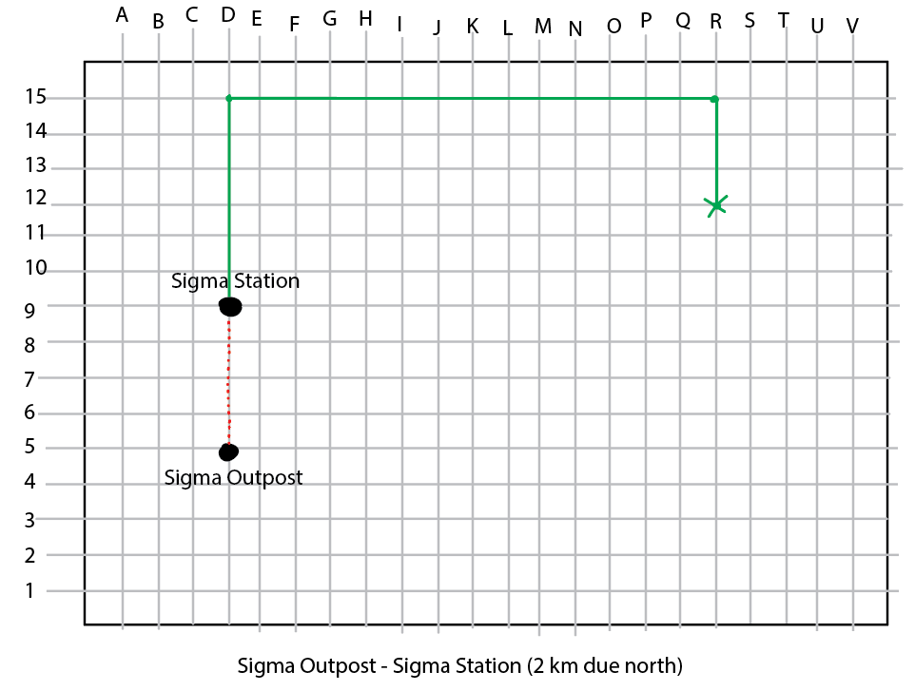

Sigma Station

1. Snowmobile

Picture: Snowmobile

Text: *"Where to next? If you know the coordinates, this vehicle can get you anywhere."*

Answer: R12

After that, a new location appears on the map - the Old Station

Old station

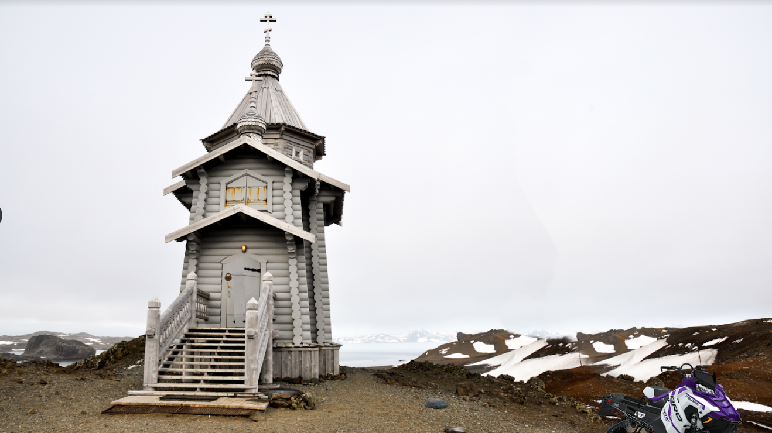

1. Stone  
   An object on the ground.

Picture: A rock on the ground

Text: *"Seems heavy."*

1. Church door before picking up the rock

Picture: A locked door of the church with a lock on it.

Text: *"Locked. A few hits might break the lock."*

1. Church door after picking up the rock

Picture: A locked door of the church with a lock on it.

Text: *"Locked. A few hits might break the lock."*

Button: Use the rock

After that, a new location appears on the map, OR the players are just automatically transported to the new location - the church.

Church

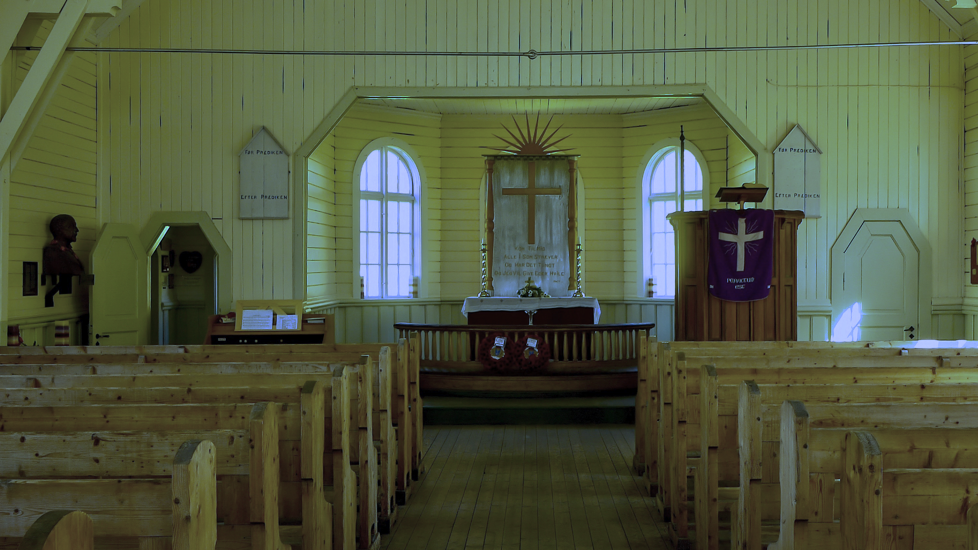

1. Holy Book

Located on the pedestal in the center.

Picture: A strange book.

Text: *"Charlie's handwriting.  
"The behind THE DOOR cannot be seen. Only felt. It speaks to us. Calls to us all. I found a way to open THE DOOR. But I will have to keep it secret. The others, like Roger, will want in. They will destroy the Seal and I can't let them do that. I must keep the secret, but it becomes harder and harder to do. I find myself mindlessly drawing strange symbols, I black out and speak a language no human ever heard… II feel IT becoming stronger. Now it can only slightly affect our minds, but it wants more. It wants to take us all and make us its puppets... It wants to control us. It wants to control us all. When it's strong enough, it will leave the Arctic and start spreading making one human after another its servant. I must stop Roger from destroying the Seal.  
I think he's plotting something. The second facility is locked, he's using it to discuss plans with his cronies.   
PS his photo gave me the clue. Expedition 1923  
sSEfF"*

Lone hut

1. Photo

Picture: A photo from an old expedition

Text: *"A photo from an old expedition. The caption reads: "Expedition ONTt"*

Sigma Station

The door of the building furthest from the player.

1. Mortuary door

Picture: A locked door.

Text: A 5-digit code.

Answer: **76854**

The players need four pieces of information to solve this one. The holy book mentioned the 1923 expedition. The Photo of the old expedition has a caption ONTt. And the diary on the Station has a hint for the code - OTtFfSsEN. The players need to figure out that the letters denote the digits. 1923 = One Nine Two three. The diary PS can be translated into One Two three Four five Six seven Eight Nine.  
 The holy book gives a combination *sSEfF =* ***76854***

After that either the new location MORTUARY appears on the screen or the players are just transported into a new location.

Mortuary

1. Roger's body

One of the bodies in the room.

Picture: A note on the body.

Text: Roger… dead. A note is clutched in his hands.  
*"This is the end. In my nightmares, I saw it. The seal. I knew that it was the key to it all. I need to break it, and this will all end. But Charlie and his men are prepared to protect the temple. This thing behind THE DOOR is getting stronger. Now it's only nightmares, but soon - full control. It will make us do whatever it wishes, and go wherever it pleases. It will guide us to the continent and there it will spread, make more thralls, like us...*

*All I needed is to open the altar in the old church. I know Charlie. Somewhere in his documents, there is a clue as to how the door can be opened. I doubt he changed the lock in the altar. His bookwormish code still stands… From right to left, the names of these stupid philosophy tomes he insisted on taking with him... But it's too late now.   
They attacked us at dawn.  
I am the last man standing. But not for long. I put all the bodies in the back… dignity is in short supply right now.   
William managed to get the communication system running right before the attack. I sent word to the mainland. I had to lie.   
I hope they will come and do what I could not.   
  
If you are reading this, I must be dead. We are all dead. I had to kill Charlie with my own hands. I had to. He was past reasoning with. I tried, I really tried.*

*End this. Break the seal."*

Church

1. Library

The library is behind the opened door in the back of the church. It is available from the go, but the letter from Roger gives an additional clue - to read the names of the tomes from right to left.fr

Picture: A row of books.  
From left to right: Solitude, Seasons, Circles of Hell, Eternity, Nothing, Five Reasons

Text: "Thick philosophy tomes.   
Solitude, Seasons, Circles of Hell, Eternity, Nothing, Five Reasons"

1. Altar before opening

Text: *"Charlie fitted a lock on the altar. There must be something important there, guarded by the 6-digit code."*

Answer: **508941**

NB: The books all point to a digit. Solitude = 1. Seasons = 4. Circles of Hell = 9. Eternity = 8. Nothing = 0. Five Reasons = 5.

1. Altar after opening

Picture: A map with strange markings.

Picture: On top -   
  
Picture: Below - a map  
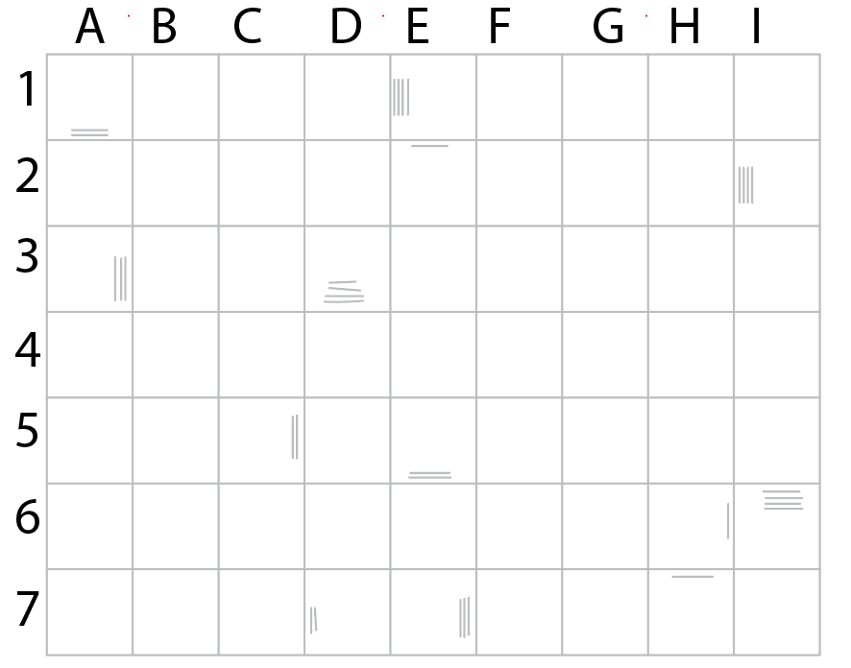

Text: "There is a note beside the map.  
*"We started from quadrant C5 and made an exploratory route around the glacier. We did not expect to find much. But at the end of the route, something caught our eye… the cave. That's where we found IT."  
Another note beneath that:   
"The seal must not be broken. Roger knows I figured out the secret of the door. He wants to meet. I suspect he will try to neutralize me and my men and then break through the door and destroy the Seal.*

*I don't want to do that. But I have to.   
We attack at dawn.  
IT becomes stronger. It wants to take over our minds and bodies. So we can't let the Seal be broken. "*

Sigma Station

1. Snowmobile

The snowmobile changes after the appearance of the Old Station location.

Picture: Snowmobile

Text: *"Where to next? If you know the coordinates, this vehicle can get you anywhere."*

Answer: **B7**

NB: The players need to check the map from the altar to figure out the location. The lines in each square show the direction and the number of steps the players need to make. The route ends on B7.  
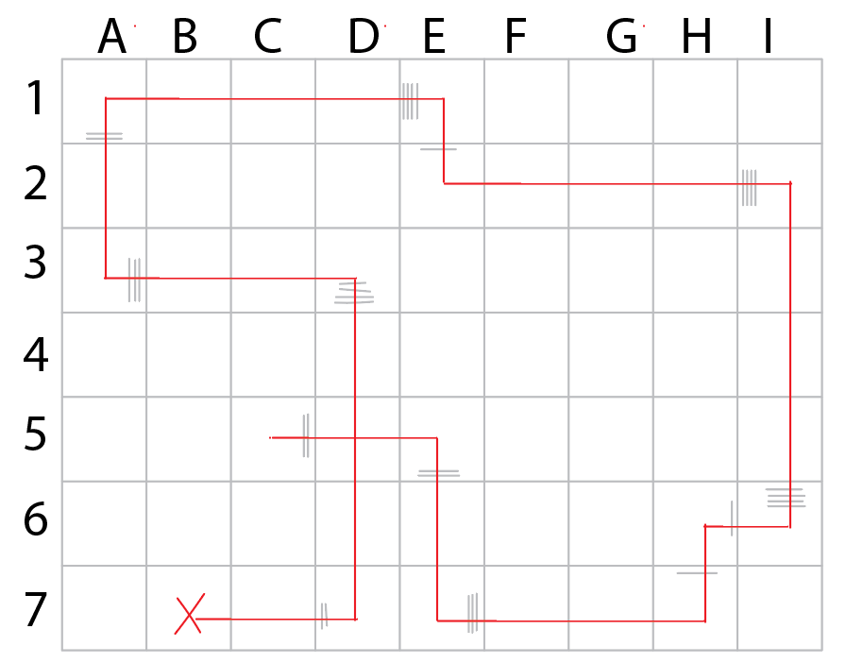

A new location appears on the map - Glacier.

Glacier



1. Cave entrance  
   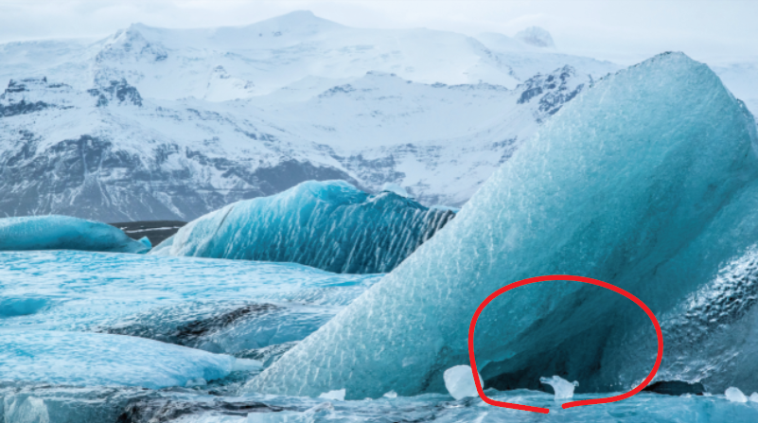

The players need to check out the location and find the only clickable spot.

Picture: An entrance to a glacial cave.

Text: An entrance to a glacial cave.  
Button: Enter

Either a new location appears on the map - Cave or the players are relocated there.

Cave

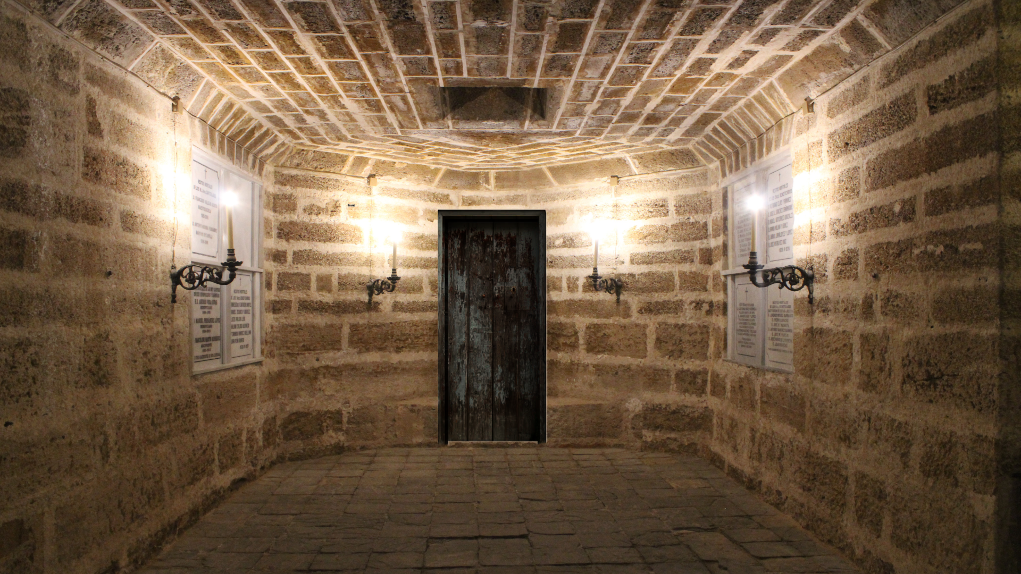

1. Temple door  
   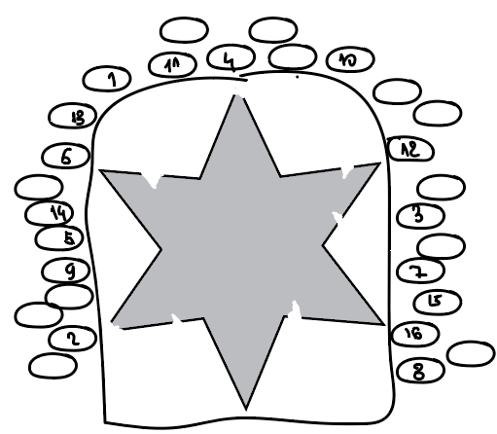

Picture: A door with a star symbol on it

Text: *"Here it is… the door. The stones around have a little give, like giant buttons..."*

Answer: **6124216**

The players need to look at the picture on the map from the altar. It shows the shapes of the ends of the star in the correct order. The ends of the star point to the correct stones.

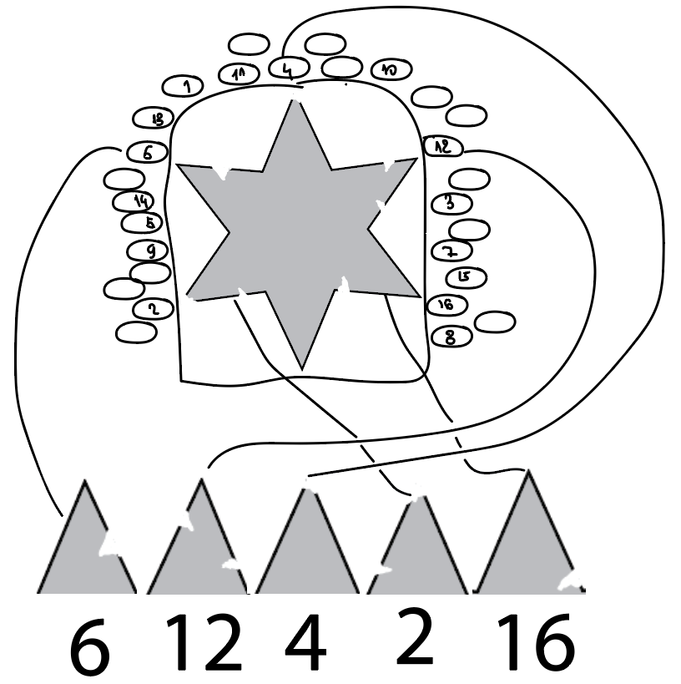

After that either the new location appears on the map - Temple or the players are automatically relocated there.

Sigma Station

1. Symbol 1

Picture: The first strange symbol  
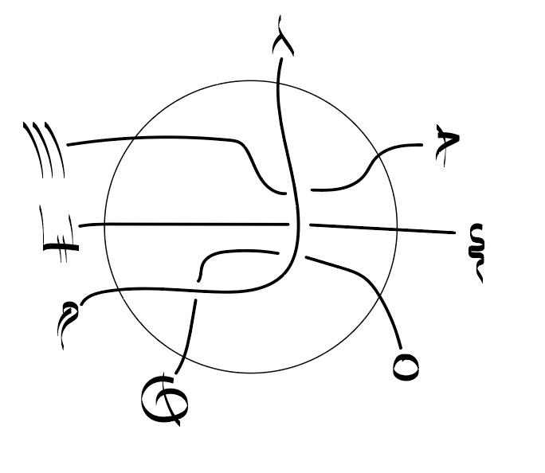

Text: *"Is this blood?"*

Outpost

1. Symbol 2

Picture: The second strange symbol  
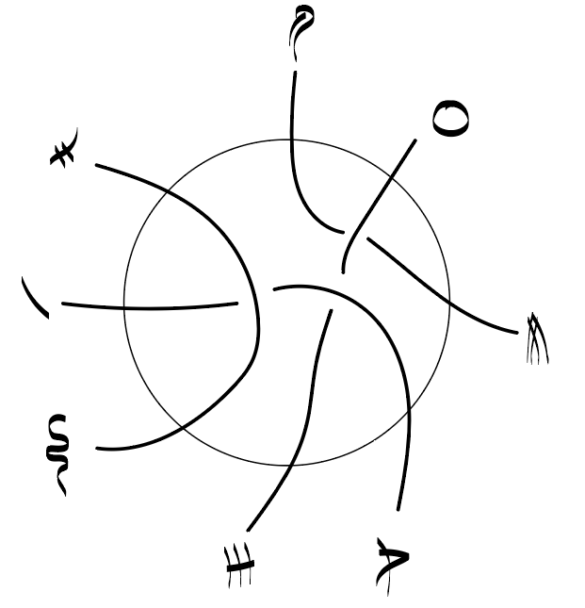

Text:  *"Is this blood?"*

Cave

1. Symbol 3

Picture: The third strange symbol  
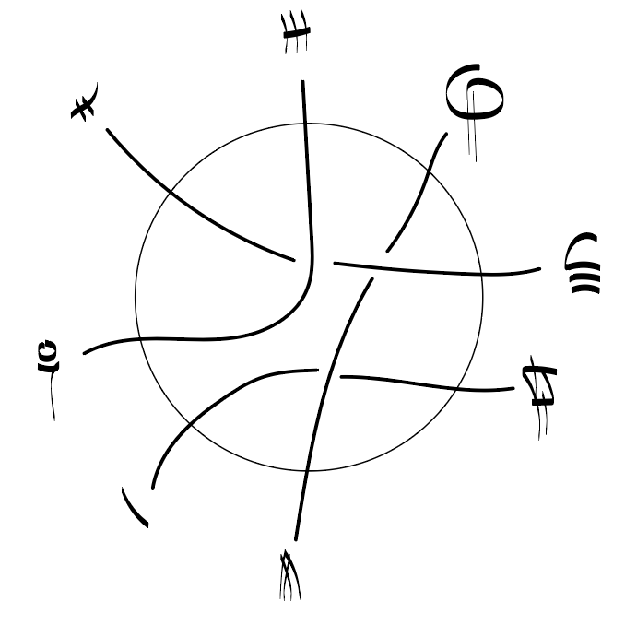

Text:  *"Is this blood?"*

Temple

1. The Pedestal

Picture: The altar in the center of the temple  
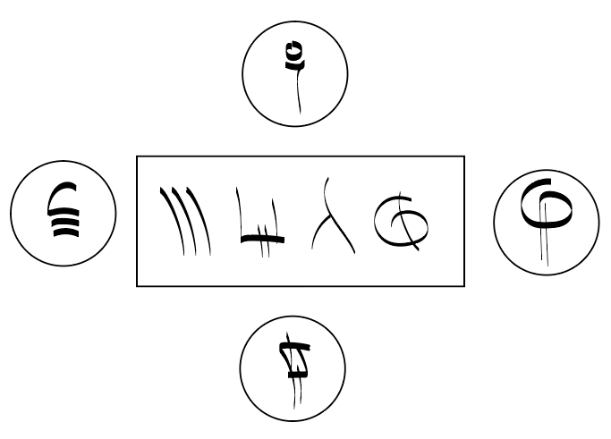

Text: *"The seal is hidden inside of this pedestal. You know it. Somehow you know it. The symbols start to glow when you touch them. All you need is the correct order of the symbols and the Seal will reveal itself."*

Answer: **1432**

The players see the symbols in the center and the glowing symbols around them. The central symbols can be found in the drawing from Sigma Station. All 4 of them have a line that goes from them to the other 4 symbols. Those symbols in turn can be found on the wall in the Outpost. Again these 4 symbols lead to other 4. And this 4 in the drawing in the Cave lead to the 4 symbols, that are glowing on the pedestal. So in the center of the pedestal is the correct order of the starting symbols, and following all the routs, the players can find the correct glowing symbols and put them in the correct order.  
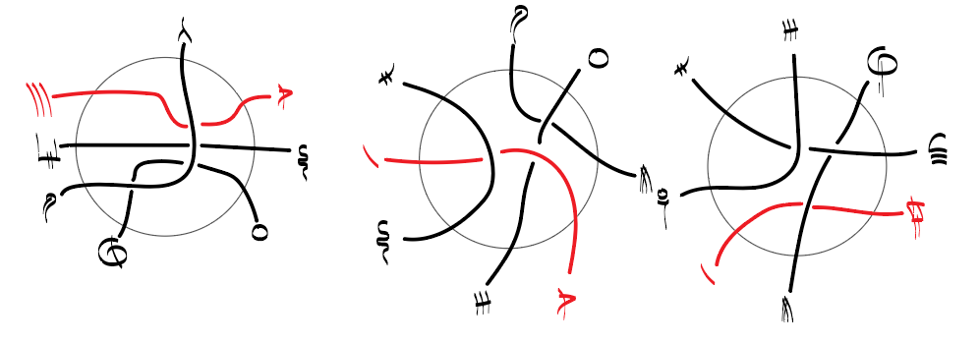

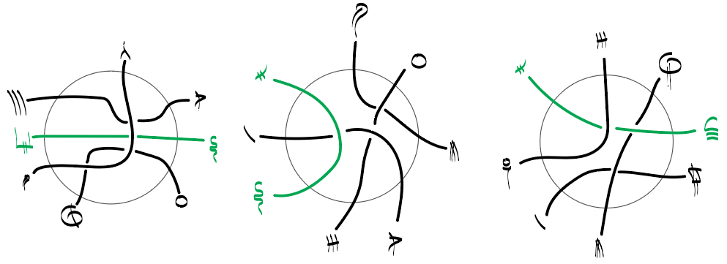

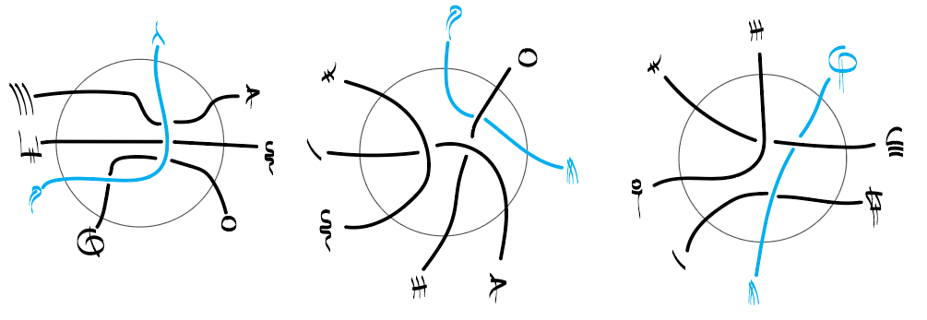

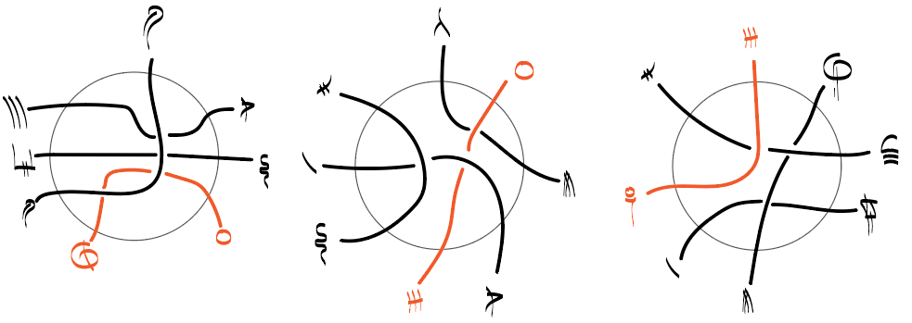

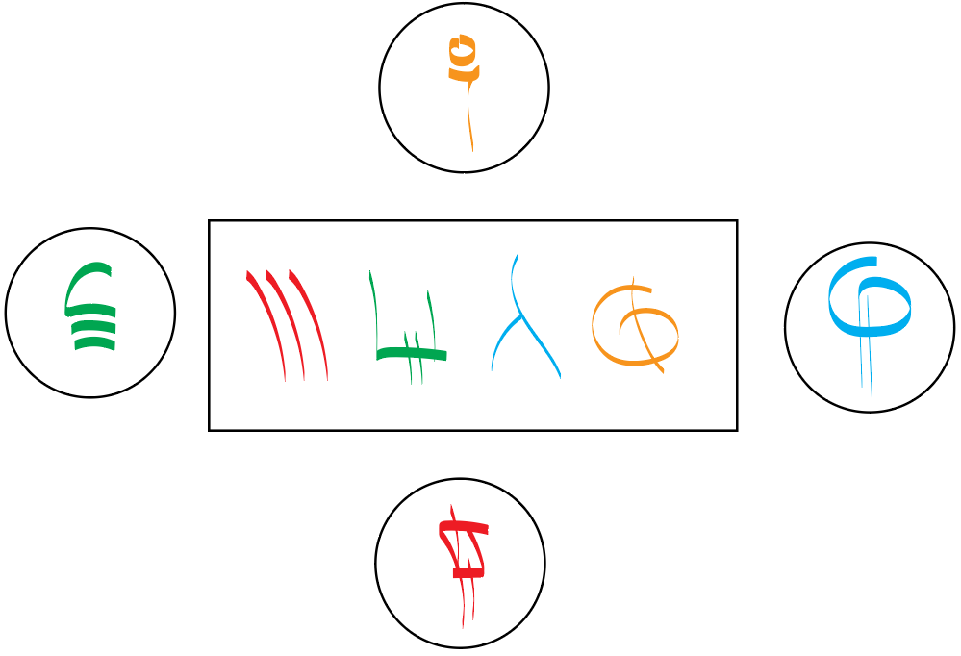

1. The seal

After opening the pedestal, clicking on the pedestal will show the seal.

Picture: The seal

Text: *"Here it is. The Seal. Charlie died trying to protect it. And Roger died trying to destroy it."*

Button: Break the seal.

After that, the players are shown a new window, with blurry visions.

1. Vision

Can be accessed by clicking the pedestal

Picture: Blurry picture

Text: *"The seal is finally broken… the visions start to flood your mind. You see blurry outlines of people, creating a stone structure in the depth of the Arctic. A structure that will serve as a prison for something powerful, something… Evil.*

*The seal is covered with runes to keep the Evil hidden, buried, imprisoned. To keep it from getting out into the world…*

*It thanks you… I... thank you. Charlie was strong… too strong. He tried to burry me. Roger was close to letting me out, but you made it happen. Now I am finally free. Shall we go? Say YES. You can't say anything else, believe me. You are mine now… but I need more. I will make them all just like you. Mine."*

Answer: **YES**

A new location appears on the map - Ship

Ship

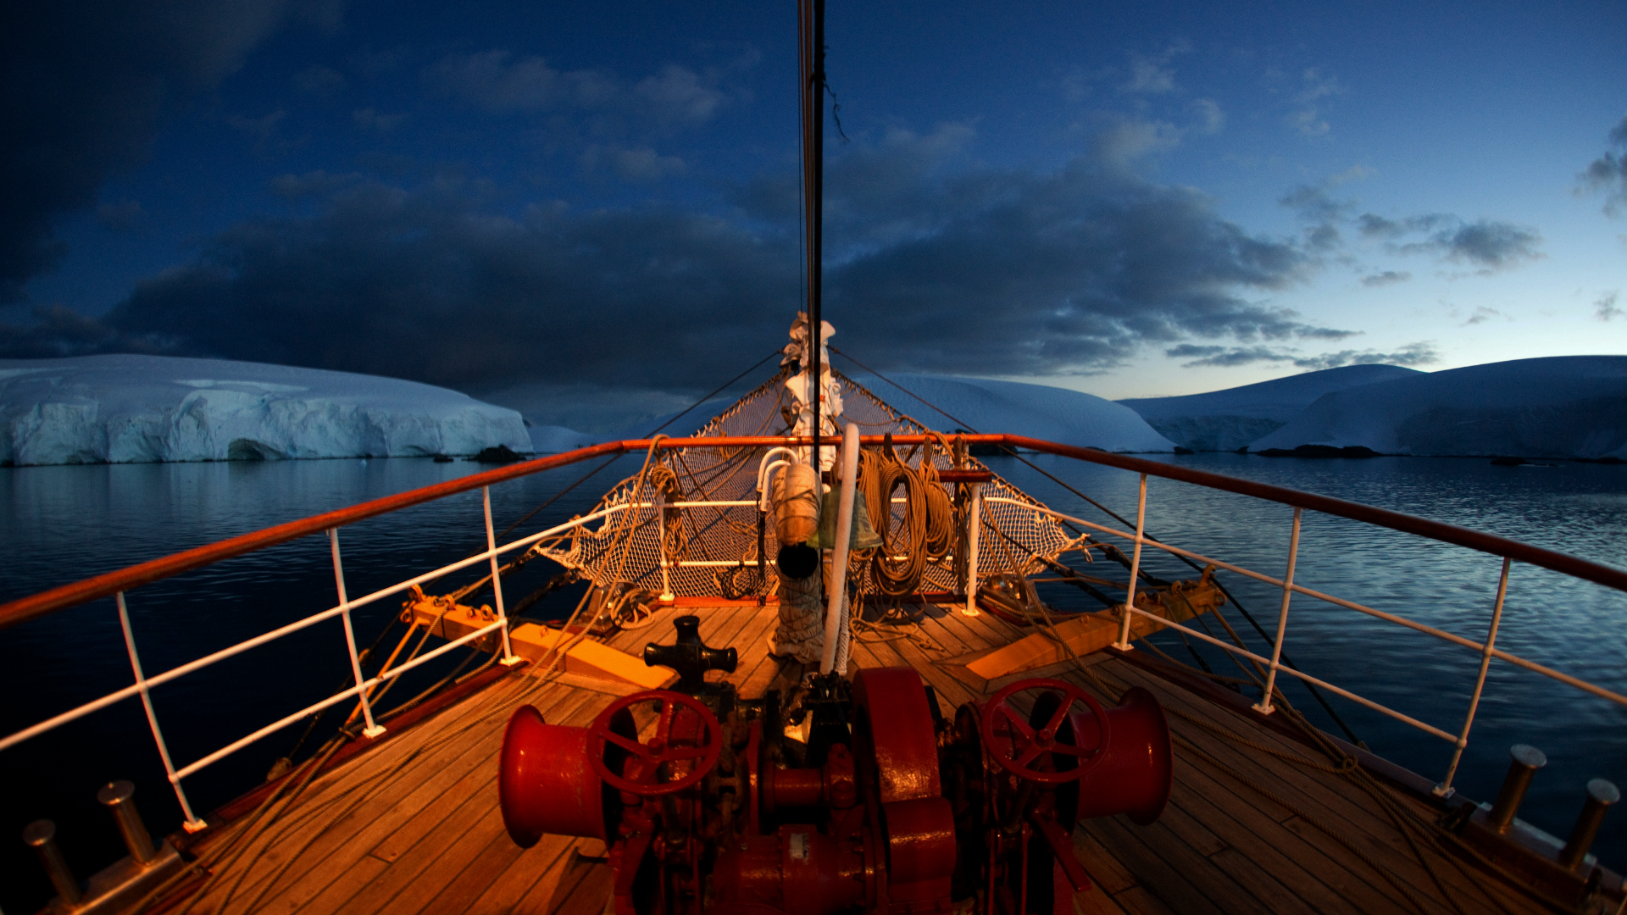

1. Outro

Picture: The boat

Text: *"You can hear the captain's voice:   
"My god… dead? All of them? This is… oh…   
Well, this is a bit much, even for me. You know what, you get back to the continent and you tell your bosses - you need compensation for that. I'm not being glib, I'm serious. This is a traumatizing experience. They should pay for this mess.*

*That's my philosophy. If you can make more - make more."  
You look at the icy ocean waters passing you by and think:  
"Yes… I will make more… much MORE".  
And you quietly sail away, towards Norway.*